**Lindsay, Norman Alfred Williams (1879-1969)**

Sarah Galletly, James Cook University

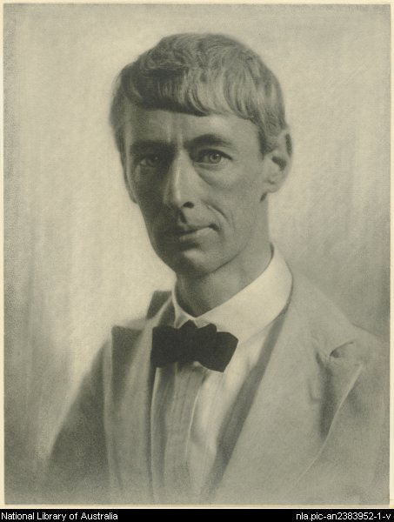**SUMMARY**

Norman Lindsay was one of Australia’s most prominent (and most notorious) artists in the early twentieth century. Throughout his extensive career he worked in a variety of media – pen and ink, oils, etching, sculpting – supporting his family through his work as a cartoonist, illustrator, journalist, and novelist. A figure of consistent media interest due to the moral outrage and questions of impropriety surrounding his extensive use of nudes and religious imagery in his artwork, his novels *Redheap* (1930) and *The Cautious Amorist* (1934) were both initially banned in Australia despite their critical and commercial success in Great Britain and the USA. Given this reputation, it is perhaps surprising that his most enduring literary contribution is his illustrated children’s novel *The Magic Pudding* (1918). Despite his early notoriety, Lindsay’s artwork sold well throughout his lifetime, his work as a cartoonist and illustrator for the *Bulletin* playing a prominent role in setting the style and tone of this iconic Australian periodical.

**Norman Lindsay photographed by Harold Cazneaux in 1920**

(url: <http://nla.gov.au/nla.pic-an2383952-1> ) - might need to declare an ‘intention to publish’ to the NLA to use this image)

**MAIN ENTRY**

Norman Lindsay was born on the 22nd February 1879 in Creswick, Victoria to Doctor Robert Charles William Alexander Lindsay and Jane Elizabeth Lindsay. Norman was the fourth son of ten children, many of whom also went on to have careers in illustration and writing. During his time at Creswick Grammar School, Lindsay worked as editor for the school’s unofficial magazine, the *Boomerang*, which had previously been edited by his older brothers Percy and Lionel. He received his chance to leave Creswick in 1896 when Lionel asked him to move to Melbourne and ghost a weekly cartoon page for the *Hawk* (later renamed the *Hawklet* to avoid legal complications) for him.

During his early years in Melbourne, Norman moved residence frequently, supplementing his income from the *Hawklet* page (which he officially took over when Lionel briefly relocated to Western Australia) with occasional commercial jobs for printers and advertisers. In 1900, Norman garnered his first mention in the *Bulletin*’s Red Page for his illustrations for Boccaccio’s *Decameron* which were being displayed at the New South Wales Society of Artists’ rooms in Sydney. This increased media profile drew the attention of two influential figures in his later career: J.F. Archibald, editor of the *Bulletin*, and Julian Ashton, a driving force behind the New South Wales Society of Artists.

Lindsay officially joined the staff of the *Bulletin* in 1901, relocating to Sydney to produce cartoons and illustrations for jokes and decorations under the watchful eye of cartoonist-in-chief Livingston Hopkins (‘Hop’). During this period Lindsay was also strengthening his reputation by illustrating works by Hugh McCrae and A.G. Stephens, and began to show a preference for the company of literary men, always keeping an eye out for young Australians whom he believed had exceptional talent or potential.

Lindsay married Katie Parkinson in 1900, when the pair were both twenty-one, fathering three sons, Jack, Raymond, and Philip, with her. Lindsay met Rose Soady a year after he began working on the *Bulletin*, while she was working as an artist’s model and they shortly thereafter became lovers. After an extensive period of estrangement, Katie finally granted Norman a divorce, and he married Rose shortly before the birth of their daughter Jane in January 1920. Their second daughter, Helen (Honey), followed in 1921.

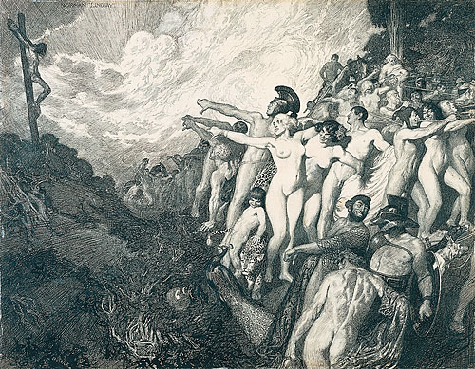During his time working at the *Bulletin*, Lindsay continued to pursue his pen and ink work, exhibiting his drawing ‘Pollice Verso’ at the 1904 exhibition for the Royal Art Society of New South Wales. The drawing, which featured a crucified man and a crowd of nude onlookers scandalised many, leading to much public outcry. However, it is important to remember that alongside his more controversial subjects, Lindsay also enjoyed drawing small boys and native animals, his koalas (or ‘native bears’ as he always referred to them) by far proving his most popular illustrated subjects.

**‘Pollice Verso’ (1904), was purchased by the National Gallery of Victoria in 1907**

(url: <http://nga.gov.au/federation/Detail.cfm?WorkID=26258&ZoomID=3> )

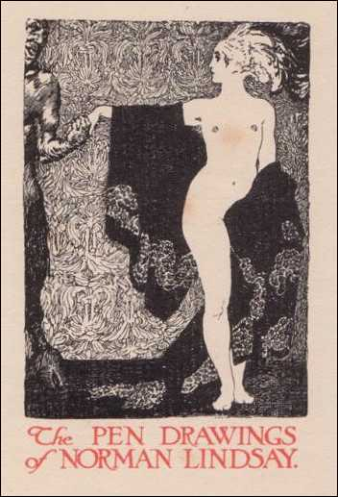In conjunction with this more commercial work, Lindsay worked over a five year period to produce illustrations for a potential new edition of *Casanova*. He was eager to try and get his hundred full-scale and 300 smaller illustrations for *Casanova* printed in a de luxe edition and, realising this was not practical in Australia’s limited marketplace, saw the need for an English publisher.

After raising funds through a series of exhibitions Lindsay headed to England in 1909 and began work on a series of illustrations for a new translation of Petronius’s *Satyricon* during the long steamship journey. Through a friendship with Ralph Strauss, who introduced Lindsay to London’s literary and artistic elite, he was encouraged to finish his Petronius illustrations so the pair could produce a limited edition deluxe run of 250 copies which quickly sold out. However, Lindsay found less success with his endeavours to print a new edition of the *Memoirs of Casanova* (largely due to a privately printed edition being seized and destroyed the year before)*.* After failed attempts to interest French publishers, and growing weary of what he saw as the degeneration of European art in the Post-Impressionist era, Lindsay responded eagerly to the call from the *Bulletin* to return to his old post back in Australia in late 1910. Lindsay became very ill upon his return from England, and he and Rose settled in Leura to aid in his recovery, finally purchasing a cottage with 42 acres of attached land in Springwood. They largely resided in this region for the rest of Lindsay’s lifetime.

**Many of Lindsay’s early *Satyricon* and *Casanova* illustrations were collected in *The Pen Drawings of Norman Lindsay* (1918)**

(url: <http://www.dropbears.com/a/artists/gallery/lindsay/001%20Pen%20Drawings%20of%20Norman%20Lindsay.htm>)

After his return from England, Lindsay was keen to produce work decidedly his own, rather than just illustrating the ideas of others. His drawing ‘The Crucified Venus’ caused a similar uproar to ‘Pollice Verso’ when it was first exhibited in November 1912 at the Society of Artists Spring exhibition. The drawing was viewed in Melbourne in September 1913 as part of the All-Australian Exhibition, where there was public demand that the picture be taken down. Ashton, still running the Society of Artists at the time, was forced to threaten to remove the whole collection if Lindsay’s drawing was not returned to public display.

Although Lindsay had occasionally dabbled in fiction since his first move to Sydney, around 1904-5 he began writing his first novel, *A Curate in Bohemia*, a tale based on his early experiences living and working with his brother Lionel in Melbourne. This novel was first published in 1913 by the NSW Bookstall Company. The novel, accompanied by illustrations by the author, became a bestseller, running into multiple editions and selling over 25,000 copies. His short story ‘Saturdee’ was first published in the *Lone Hand* on 1 July 1908, and is notable for including the first mention of the town of Redheap, which stood in as the fictional counterpart to his childhood home of Creswick.

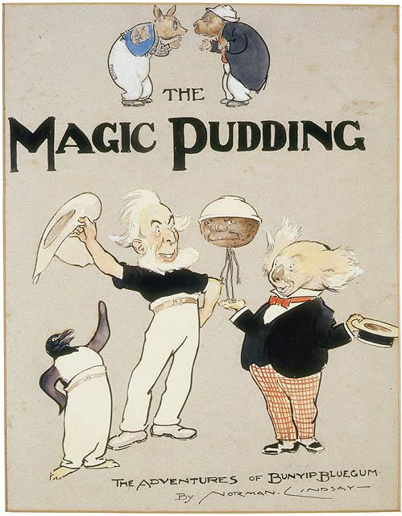In 1913, Hopkins retired from the *Bulletin*, allowing Lindsay to take a more prominent role, leading to the production of some of his most political and propagandist illustrations during the war. During the First World War Lindsay also began to write his tale for children, *The Magic Pudding* (1918) which would go on to become one of his most well-known and popular pieces of fiction. The story was conceived through a casual discussion with Bertram Stevens about the significance of food in children’s minds, its story focusing on the figure of Bunyip Bluegum, a native bear who had featured in some of his earlier drawings for the *Bulletin* and the *Lone Hand*. It did not appear until 1918 due to wartime restrictions, and although it was priced at a guinea, the book sold well with over 100,000 copies printed in Australia

**Frontispiece for first edition of *The Magic Pudding* (1918)**

(url:<https://upload.wikimedia.org/wikipedia/en/f/f9/The_Magic_Pudding.jpg> )

The Great War only reinforced Lindsay’s beliefs in the moral exhaustion of European art and society, a position which he felt had only been aggravated by the neuroses engendered by a global conflict. Lindsay published the thinking behind his changing artistic perspective in *Art in Australia* in 1920 and more comprehensively in *Creative Effort* (1924). Drawing from Plato and Nietzsche, Lindsay constructed a philosophy of art and life that denied the influence of all social and political progress on art. He believed that creative artists were all products of the same family tree and this race of ‘Olympians’ revealed themselves in acts of creativity which set great painters, sculptors, poets, musicians and writers apart from, and above, ordinary ‘Earth Men.’ Lindsay saw modernist art as one of the most recent manifestations of an unending attack on his masculinised creative elite.

Lindsay briefly retired from the *Bulletin* in 1923 to focus on his art work, and shortly thereafter his work was again singled out for public controversy at events such as the Australian Art Exhibition in London in 1923, where his work was seized by customs upon inspection. Similarly in Artists Week in Adelaide in July 1924, three of his etchings were banned from public display. Lindsay continued to make good money from his exhibited works, yet the press continued to protest and sensationalise his work and its impact. He also ventured into etching after the war, with his partner Rose carrying out the labour of printing the etchings herself, and published over two hundred etchings across his lifetime.

During this period, Norman also encouraged his son Jack Lindsay, who had moved to Sydney from Queensland in 1921, to launch a literary quarterly with Kenneth Slessor and Frank Johnson. He promised to provide a set of black and white decorations for each issue and write short stories and literary essays to help promote the publication, as well as providing its title. *Vision* launched on the 1st May 1923 and only lasted for four issues, largely due to financial constraints. He continued to collaborate with Jack, illustrating his translation of *Lysistrata* (1925), and providing material (both illustrative and literary) for his Fanfrolico Press imprint.

In 1930, Lindsay’s novel *Redheap* (written fifteen years previously) was published by Faber and Faber. *Redheap* was greatly influenced by his brother Lionel’s diary of their adolescence in Creswick, the novel parodying several prominent members of their former community. Only a few days after its first review, Horace Richardson spoke in State Parliament appealing to the Federal Government to ban *Redheap* largely due to Lindsay’s existing artistic reputation for moral 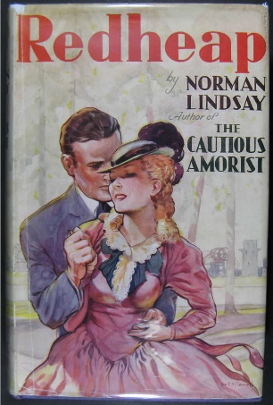impropriety. By May 21st 1930, *Redheap* was prohibited from entering Australia*.* Nevertheless, *Redheap* sold well in England and was published later that same year in the United States under the title of *Every Mother’s Son*, proving itself an immediate critical and popular success.

**Cover for the first Faber and Faber edition of *Redheap* (1930)**

(url: <http://www.apfa.esrc.unimelb.edu.au/objects/images/redheap.jpg> )

Likely building upon this controversy, a special ‘Norman Lindsay Number’ of *Art in Australia* which had initially sold well in late 1930 was seized by police in June 1931 and the journal editors, Sydney Ure Smith and Leon Gellert*,* were required to appear in court under charges of issuing an ‘obscene publication.’ These charges were swiftly dropped but continued to draw attention to Lindsay’s supposed ‘immorality’.

Unsurprisingly after these compounding controversies, Lindsay was eager to escape Australia, booking himself and Rose on a trip to the United States in mid-1931 where his work was soon found to be in great demand. *Cosmopolitan* magazine paid him $1000 to illustrate a short story and pressed him to sign a three-year contract. He finished writing his novel *Mr Gresham and Olympus* (1932, published elsewhere as *Miracles by Arrangement*) during his time in New York, and it was accepted by the first publisher who saw it, Farrar and Rinehart, for a $1000 advance. This success also led to the publication of *The Cautious Amorist* (1934), a comic tale about the adventures of three men and a young woman cast away on a Pacific Island. This novel, written some twenty years previously, was inspired by a real incident where his friend Ralph Stock, his sister Mabel, and another man wrecked themselves on a reef off Norfolk Island.

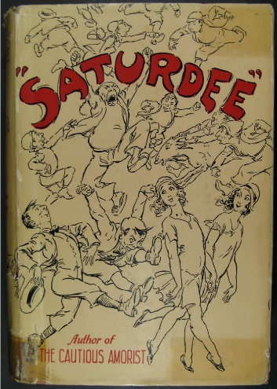Lindsay returned to Australia and the *Bulletin* in 1932 after a brief trip to England and used his connections there to launch the Endeavour Press, a publishing house dedicated to promoting Australian authors. The Press was officially launched via the editorial page of the *Bulletin* in November 1932, and P.R. Stephensen, whom Lindsay had met during his time in England returned to Australia to manage it. Struggling to find material of sufficient quality, Lindsay instead launched the Press by collecting together seventeen short stories he had previously written for the *Bulletin* and the *Lone Hand* in *Saturdee* (1933), rewriting many of them so that they weaved together as one narrative. Seemingly over-estimating Australian interest in indigenous books, the press only published twenty novels during its first few years and after failing to make a profit, was officially dissolved in 1934. Building upon this disappointment, Australian authorities banned *The Cautious Amorist* in the same year.

**The cover of the 1936 T. Werner Laurie edition of *Saturdee***

(url: <http://www.apfa.esrc.unimelb.edu.au/image_viewer.htm?objects/images/saturdee.jpg,D00001216> )

In 1934, Lindsay leased a studio flat at 12 Bridge Street, Sydney, just around the corner from the *Bulletin* offices and took time away from his wife and children to focus on his artwork, focusing particularly on his oil painting. However, he continued to occasionally produce literary material during this period, most notably his novel *The Cousin from Fiji* (1945), considered by many to be his most skilfully constructed novel. During this period he produced artistic works such as ‘Don Juan,’ ‘Reverie’ and ‘Imperia.’

By the late 1940s, Lindsay asked for his *Bulletin* workload to be eased slightly, though he still regularly contributed joke drawings and illustrations. He was unceremoniously dismissed from the *Bulletin* in 1958, but through his friendship with Red Page editor Douglas Stewart, he still continued to submit written material to the *Bulletin*. By the late 1950s, literary censorship was beginning to ease in Australia and *The Cautious Amorist* and *Redheap* were finally considered ‘unobjectionable.’ The first Australian edition of *Redheap* was released in 1959.

In his late eighties Lindsay hatched a plan to sell his Springwood house and grounds to the National Trust of Australia (New South Wales), to serve as a Norman Lindsay gallery and museum. However, the costs of getting the property ready for the National Trust’s purchase proved heavy and he was forced to arrange an exhibition of his work in 1969 to help keep himself solvent. Shortly after the success of this exhibit he was admitted to Springwood hospital and died on the 21st November 1969.

**List of Works**

Fiction

*A Curate in Bohemia* (1913)

*The Magic Pudding* (1918)

*Madam Life’s Lovers* (1929)

*Redheap* (1930) (Published in US as *Every Mother’s Son*)

*Miracles by Arrangement* (1932) (Published in US as *Mr Gresham and Olympus*)

*Saturdee* (1933)

*The Cautious Amorist* (1934)

*Pan in the Parlour* (1934)

*The Flyaway Highway* (1936)

*Age of Consent* (1938)

*The Cousin from Fiji* (1945)

*Halfway to Anywhere* (1947)

*Dust or Polish?* (1950)

*Rooms and Houses* (1968)

Non-Fiction

*Creative Effort* (1920) (significantly revised UK edition published in 1924)

*Hyperborea* (1928)

*Bohemians of the Bulletin* (1965)

*Norman Lindsay Ship Models* (1966)

*The Scribblings of an Idle Mind* (1966)

Autobiography

*My Mask* (1970)

Pictorial Works

*The Pen Drawings of Norman Lindsay* (special number of *Art in Australia*)(1918)

*Pen Drawings: Norman Lindsay* (1924)

*The Etchings of Norman Lindsay* (1927)

*Art in Australia: Norman Lindsay Number* (1930)

*Norman Lindsay’s Pen Drawings* (1931)

*Norman Lindsay: Water Colour Book* (1939) (extensively revised and republished as *Norman Lindsay Watercolours* in 1969)

*Paintings in Oil* (1945)

*Norman Lindsay: Selected Pen Drawings* (1968)

*Norman Lindsay Pencil Drawings* (1969)

**Further Reading**

Bloomfield, Lin (ed.) (1979) *The World of Norman Lindsay*, South Melbourne: Macmillan.

Chaplin, Harry F. (1969) *Norman Lindsay: His Books, Manuscripts and Autograph Letters in the Library of and Annotated by the Author,* Sydney: The Wentworth Press.

Hetherington, John. (1973) *Norman Lindsay: The Embattled Olympian*, Melbourne: Oxford University Press.

Lindsay, Jack (1970) ‘Norman Lindsay: Problems of his Life and Work,’ *Meanjin Quarterly* xxix: 39-48.

Slessor, Kenneth (ed.) (1959) *Southerly; Norman Lindsay Number*, Sydney: Angus & Robertson.

Smith, Bernard (1986) ‘Lindsay, Norman Alfred (1879-1969),’ *Australian Dictionary of Biography*, National Centre of Biography, Australian National University.

Stewart, Douglas (1975) *Norman Lindsay,* Melbourne: Nelson.